Operation Tractable
34
MILITARY
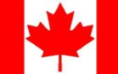
1ST CAN
AIR POWER
Jabos: +1 1st Can;
Carpet Bombing
RESOURCES
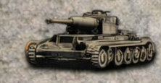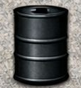
1 x Kampfgruppe* Lose 1
*Deploy to map or Strategic Reserve for 1 Action

ORDERS: 3 Actions
-1 DRM Transport
+1 Attack Strength 1st CAN
Operation Tractable was the final offensive conducted by Canadian Army and Polish Army troops as part of the Battle of Normandy. The goal of this operation was to capture the strategically important French town of Falaise. This operation was undertaken by the Polish 1st Armoured Division and the First Canadian Army.

